Competitive Shooters of Lake Norman USPSA February 13th, 2026
COURSE DESIGNER: Ike Starnes
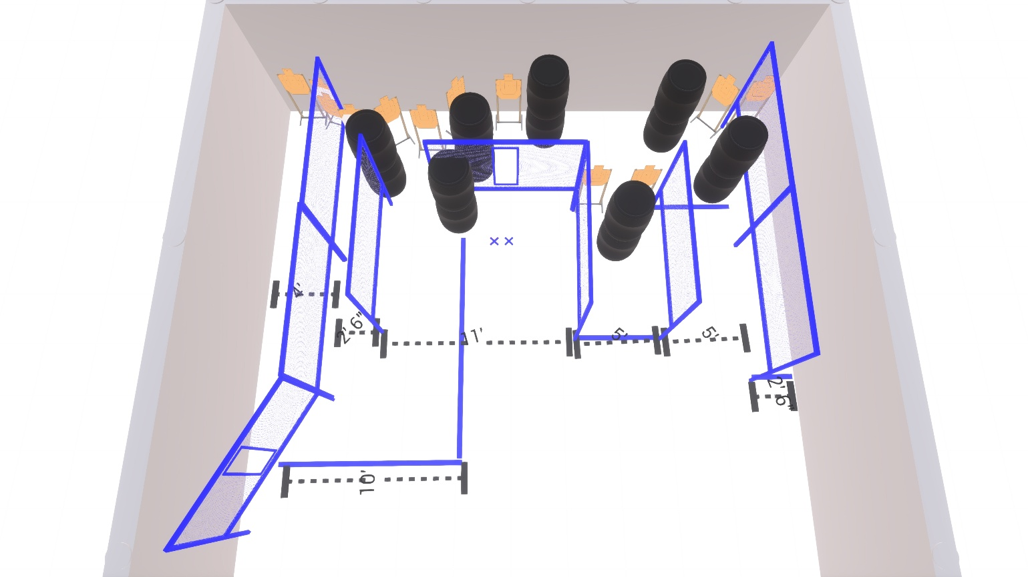

Stage 3 – Luck is believing you’re lucky
26 rounds, 130 points, Comstock
There are 13 cardboard targets with some no-shoots.
Starting with feet on both Xs.
Handgun is unloaded and holstered, wrists below belt.
PCC is unloaded held in both hands, stock touching belt.
On the audible start signal, engage targets from within the shooting area.

